Video code:
https://vimeo.com/524708425
Please place the video at the top of the online story if at all possible and feature a pointer to it in the print newspaper please?

Whanganui Chronicle
Sarjeant Gallery Redevelopment Update
By Gaye Batty – Project Director
An early milestone is reached on the Sarjeant Gallery redevelopment
The concrete foundations are currently being formed and poured for the Sarjeant Gallery’s new extension, including the basement floor where the artworks collection will be housed.
The Sarjeant Gallery redevelopment project involves earthquake strengthening the existing heritage building and construction of a new wing – Pataka o Sir Te Atawhai Archie John Taiaroa, named in honour of the much loved Whanganui kaumatua.
To date, roughly 310 cubic metres of concrete have been poured for the extension and 25 cubic metres for the existing building. It has taken about 850 hours to pour the concrete so far.
Being done by the main contractor McMillan & Lockwood Central Ltd and their subcontractors, the concreting work includes forming the foundation beams, isolated pads, floor slabs and the placement of reinforcing steel. The quality of the work is being checked by local and Wellington based structural engineers to ensure compliance with the documents and building consent.
Most of the concrete poured to date has been for the back half of the foundations for the extension towards the existing Gallery building. A critical part of the project, these foundations will be built upon three stories high.
The Gallery extension involves construction at the rear of the existing 100-year-old Gallery building including removal of trees, some additions and changes to the roads and footpaths, service installations and landscaping and planting.
Concrete pouring continues for the remaining foundations, walls and floors of the extension. At the same time the existing Gallery has been prepared for the structural strengthening required for earthquake resistance including new concrete foundations and walls.
All construction earthworks were assessed and monitored by an archaeology team and iwi representatives, in preparation for the construction of the new wing.

Photo captions:
- McMillan and Lockwood contractors reach a significant milestone at Sarjeant Gallery redevlopment project with the concrete foundations for the new wing being laid
- Concrete pouring continues for the remaining foundations, walls and floors of the extension.

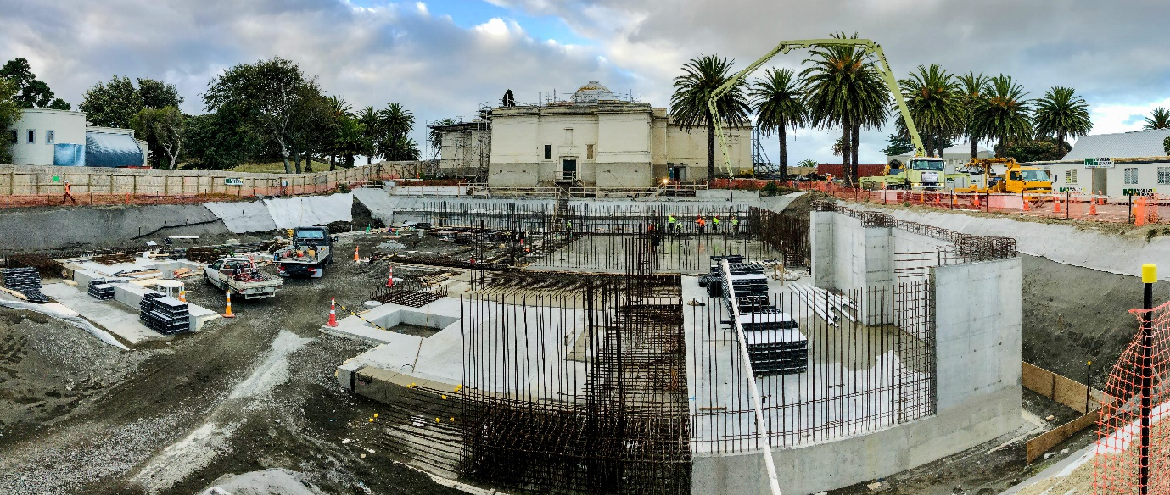1. McMillan and Lockwood contractors reach a significant milestone at Sarjeant Gallery redevlopment project with the concrete foundations for the new wing being laid
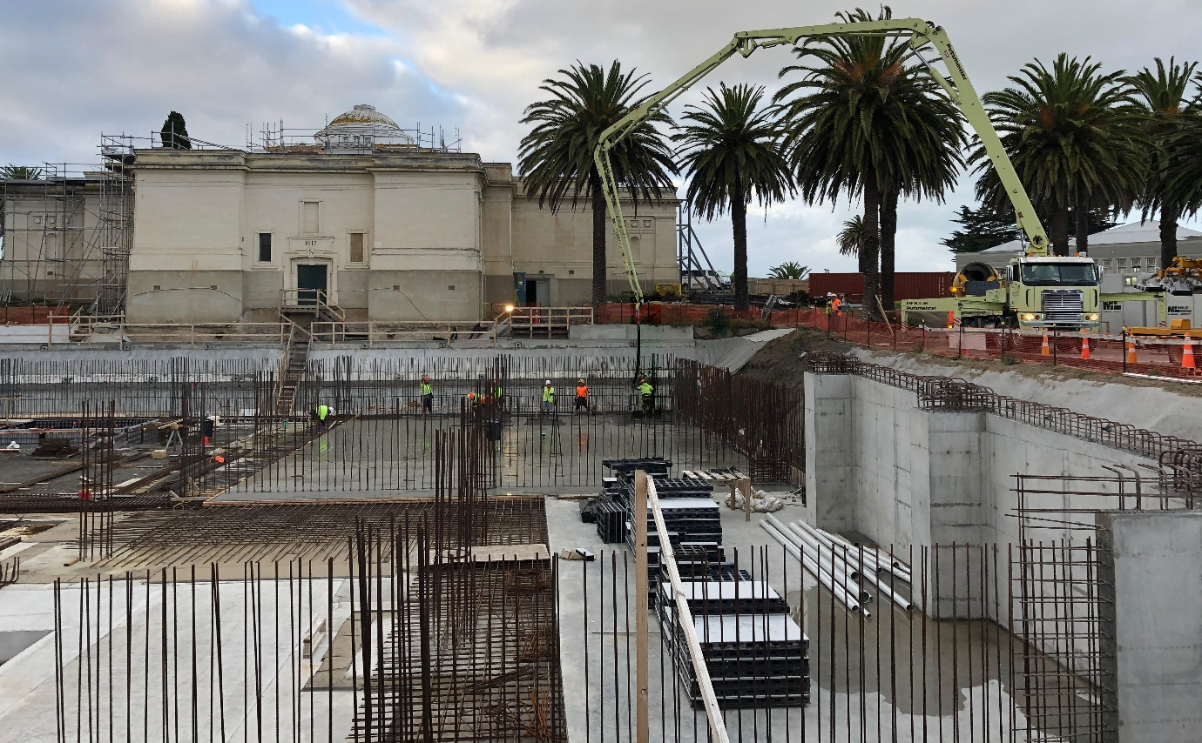
- Concrete pouring continues for the remaining foundations, walls and floors of the extension.

